

Integration Requirements

Promotions Interface (J114) from IDS to GFO

Author: Heather Rennoldson

Version: 0.1

Date: 07/03/2007

Status: Draft

Table of Contents
1. Introduction 4
1.1 Background 4
1.2 Issues 4
2. Promotions in the IDS 5
2.1 Overview 5
3. Requirements 7
3.1 GFO requirements 7
3.2 Logic for extracting from the IDS 7
3.3 Additional notes 7
Appendix A Promotions File Mappings 8
Appendix B Glossary of Terms 9

Document Control

Project: | Operating Model – Integration
Document Title: | Requirements Definition
Document Location: | Docshare
Distribution: | Lewis Stewart  Adrian Hinks  Allistair Green  Nikhil Rajwade  Nuno Carvalho | GFO  )  )  )TOM Integration team  )  )

Change Record

Date | Version | Change Description | Author
07/03/2007 | 0.1 | Initial Draft | Heather Rennoldson

References

Document | Version | Date | Author

Introduction

Background

The purpose of this document is to confirm the business requirements for the promotions interface from the Integration Data Store (IDS) to Group, Forecast & Order (GFO) for Turkey. The information is based on the requirements for the GFO Promotions Interface file mappings (see Appendix A) and conversations with the GFO team.

This covers the requirements for the J114 interface (Promotion Data IDS to GFO).

Promotions are structured in a different manner within ORMS10, so the GFO requirements for this data have been documented separately, although the ultimate receiving file/table will be the same format.

Issues
The promotion identifier used within ORPM (and also ORMS) allows for 10 digits, but that within GFO only allows for 9 digits.

Promotions in the IDS

Overview
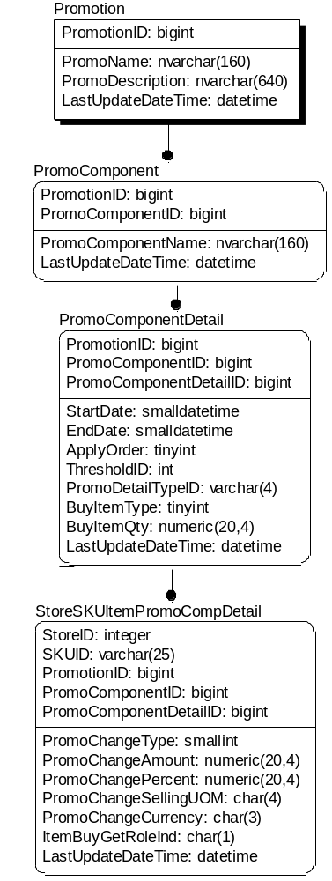

The diagram above portrays how the Integration data Store (IDS) holds promotional data. This is broadly in line with the ORPM tables.

All the promotion data within the IDS has been exploded to Store/SKU level, so GFO will not receive any details of subgroup promotions.
The interface has been designed to recognise ‘simple’, ‘threshold’ and ‘buy-get’ promotions. However, for the first year of operation, the US will only use feature promotions i.e. simple promotions with a ‘change type’ representing ‘no change’. These will be represented as ‘SKU’ promotions to GFO.

Only approved promotions will be held in the IDS.

Table | Description
Promotion | This holds the major promotional information – promotion, promotion name.
PromComponent | This describes a lower level of the promotion. Deals would be set at this level within ORPM but these are not captured in the IDS.
PromoComponentDetail | This has the start and end dates of the promotion and also indicates what type of promotion it is – simple, buy-get or threshold
StoreSKUItemPromoCompDetail | This contains the products on promotion linked to the stores

Requirements

GFO requirements
1. GFO require a Promotions interface provided daily (probably c 2200hrs but requires confirmation).

2. This will contain details of all SKUs on promotion currently, and at any time in the next 31 days. The data required is independent of the stores linked to the promotions.

3. GFO requires a complete file every day – not deltas.

Logic for extracting from the IDS

- Select Promotion ID, PromoComponentID, PromoComponentDetailID, PromoDetailTypeID from PromoComponentDetail which are current between now and 31 days ahead i.e. where
StartDate is <= control date + 31 days and EndDate is >= control date.
(I assume that the control date will actually be ‘tomorrow’, since GFO is receiving a file tonight for action tomorrow)
.
The following paragraphs indicate how to identify the items in the promotion;

- Select SKUID from StoreSKUItemPromoCompDetail where PromotionID, PromoComponentID, PromoComponentDetailID = that obtained above

- Remove duplicates

Additional notes
Since a promotion can transfer from approved back to worksheet status, it is possible that a promotion will disappear from the file, before the promotion is extracted.

- Promotions File Mappings

GFO Integration Layer Promotions File |  |  |  |  |  | IDS Source
Data Item | Data Type | Data Length | Fixed Data | Data Format |  | Table | Data Item | Data Type | Data Length | Notes?
JIPMA-RECORD-TYPE | NUMERIC | 2 | "00"
JIPMA-DATE | CHAR |  |  | CCYYMMDD
FILLER | CHAR |  | SPACES
JIPMB-RECORD-TYPE | NUMERIC | 2 | "01"
JIPMB-BASE-PRODUCT-NO | CHAR | 9 |  |  |  | StoreSKUItemPromoCompDetail | SKUID | varchar | 25
FILLER | NUMERIC | 5 | ZEROES
FILLER | CHAR | 1 | SPACES
JIPMB-PROMOTION-START | NUMERIC | 8 |  | CCYYMMDD |  | PromoComponentDetail | StartDate | smalldatetime
JIPMB-PROM-END-DATE | NUMERIC | 8 |  | CCYYMMDD |  | PromoComponentDetail | EndDate | smalldatetime
JIPMB-BPR-UPLIFT-PERC | NUMERIC | 8 | ZEROES | +/-9999999
FILLER | CHAR | 1 | SPACES
FILLER | CHAR | 48 | SPACES
JIPMB-OFFER-ID | CHAR | 9 |  |  |  | Promotion | PromotionID | biginit
JIPMB-OFFER-DESC | CHAR | 50 |  |  |  | PromoName | PromoName | nvarchar(160) | 160
JIPMB-OFFER-BUKT-REQD | CHAR | 1 |  |  |  | ? | ? | ? | ? | Will be set to ‘N’
JIPMB-FEATURE-SPCE-DISP | CHAR | 1 | "Y"
JIPMB-BPR-REGN | CHAR | 2 | "00"
JIPMB-AREA-CD | CHAR | 1 | "1"
JIPMB-OFFER-TYPE | CHAR | 3 |  |  |  | PromotionComponentDetail | PromotionDetailTypeID | varchar | 4 | ‘BWG’ if PromotionDetailTypeID = B  ‘THR’ if PromotionDetailTypeID = T  ‘SKU’ if PromotionDetailTypeID = S
FILLER | CHAR | 84 | SPACES
JIPMZ-RECORD-TYPE | NUMERIC | 2 | "99"
FILLER | CHAR | 241 | SPACES
JIPMZ-REC-COUNT | NUMERIC | 7

- Glossary of Terms

Mnemonic | Description
GFO | Group Forecast & Order
IDS | Integration Data Store
ORMS | Oracle Retail Management System
ORPM | Oracle Retail Price Management
POS | Point of Sale
RIB | Retek Integration Bus

